# Proposal for

Website to help with wedding arrangements

# Project name:

# ”Wedding Assist”

Submitted by:

## Sumaiya Afroz Sara

**ID: 1911236642**

**Section:01**

Github link: https://github.com/sarasumaiya/CSE311Project-Wedding-Assist

**Introduction:**

Most families in our country like to celebrate weddings grandly with friends and family. Thus the organization of a wedding following our wedding culture is quite tiresome and requires a lot of time to look for different vendors that align with the overall requirements. Despite this hectic wedding culture we follow, there is very few application or websites to help in the process. Thus this web application will help organizing weddings so that the entire tiring process can be easy and time-effective. This platform will help look for wedding vendors such as photographers, makeup artists, caterers, decorators etc. Without much hassle.

**Purpose and Benefits:**

Decrease the hassle of finding and contacting hundreds of different vendors. Thus both time and energy will be saved. New vendors without any platform will get an immediate platform to get clients.

Key Benefits:

* All vendors under one roof, less trouble, less wastage of time.
* An online platform for both new and old vendors to get potential clients.

**USE CASE 1:**

Mr. Abc, wants to look for certain vendors for his/ his relative’s wedding:

a) He can sign-up in the wedding assist website and go looking for a particular type of vendor by selecting that department.

b) If his requirements matches, he can contact them for a meeting for further discussion. The vendor will get notified when Mr.Abc selected them so that they can contact back.

**USE CASE 2:**

Vendor XYZ, wants to sign up as a vendor to attract potential clients. He will have to sign up with necessary information and after signing up, he can further update information about their business.

Front end plan

1. Main page

2. Client Login page

3. Client Sign-up page

4. Vendor Sign-up page

5. Vendor Login-in page

6. Vendor profile update page

7. Client vendor category selecting page

8. Different vendor information pages for each category of vendors

Back end plan

1. Account Creating
2. Sign up

3. Login

4.Vendor details

5. Vendor Details update

6. Book Meeting

Tools and Technologies

1. Database: Mysql

2. Protocol: Http

5. PHP

6.CSS

7.Javascript

8.Bootstrap

Some Screenshots of Project:

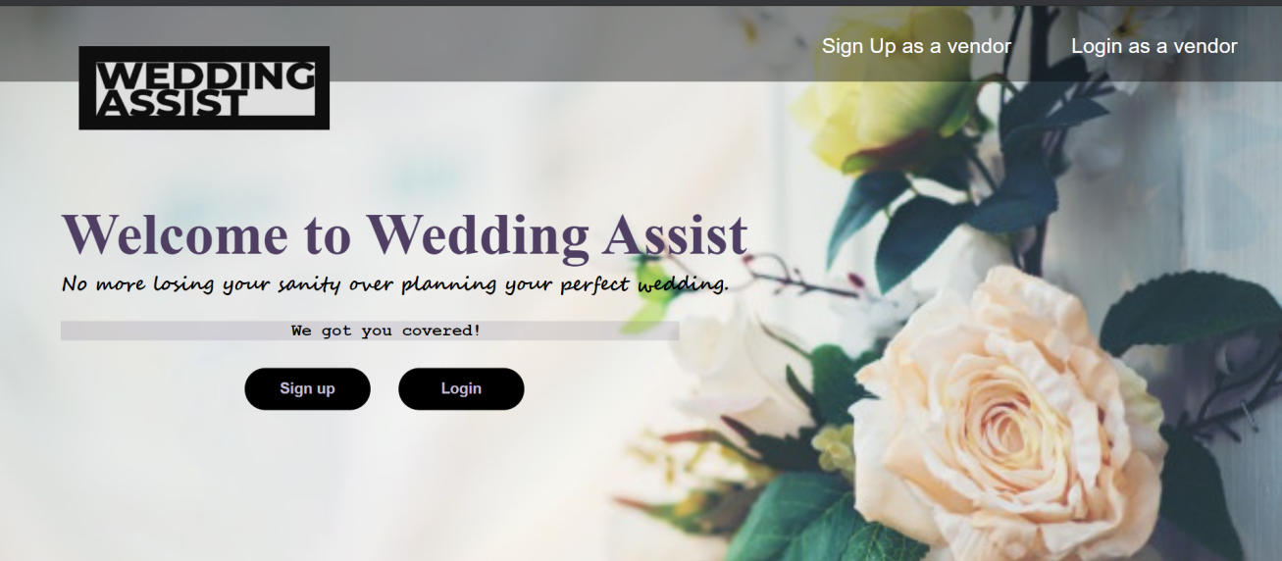

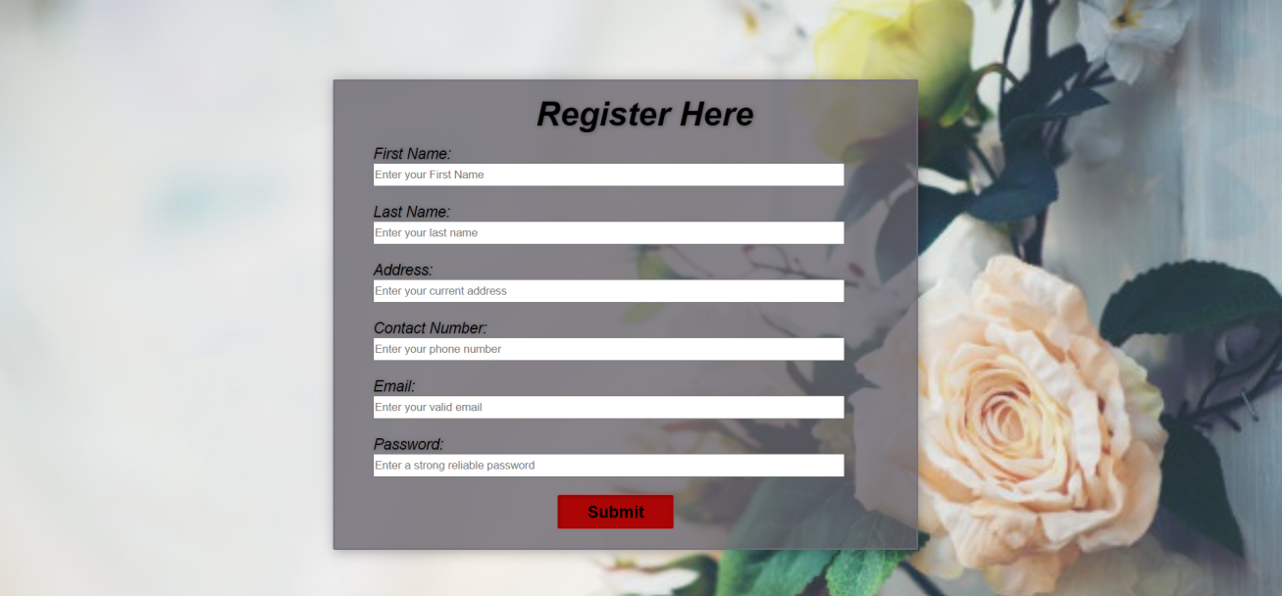

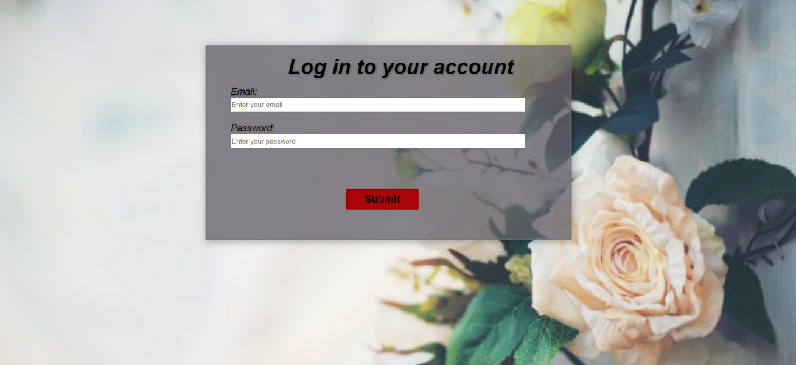

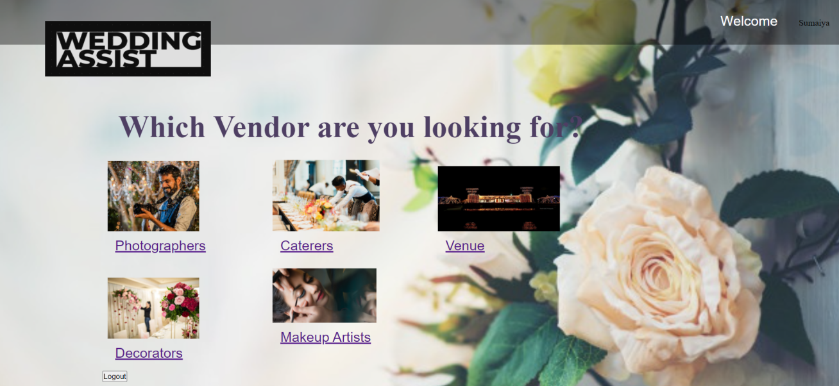

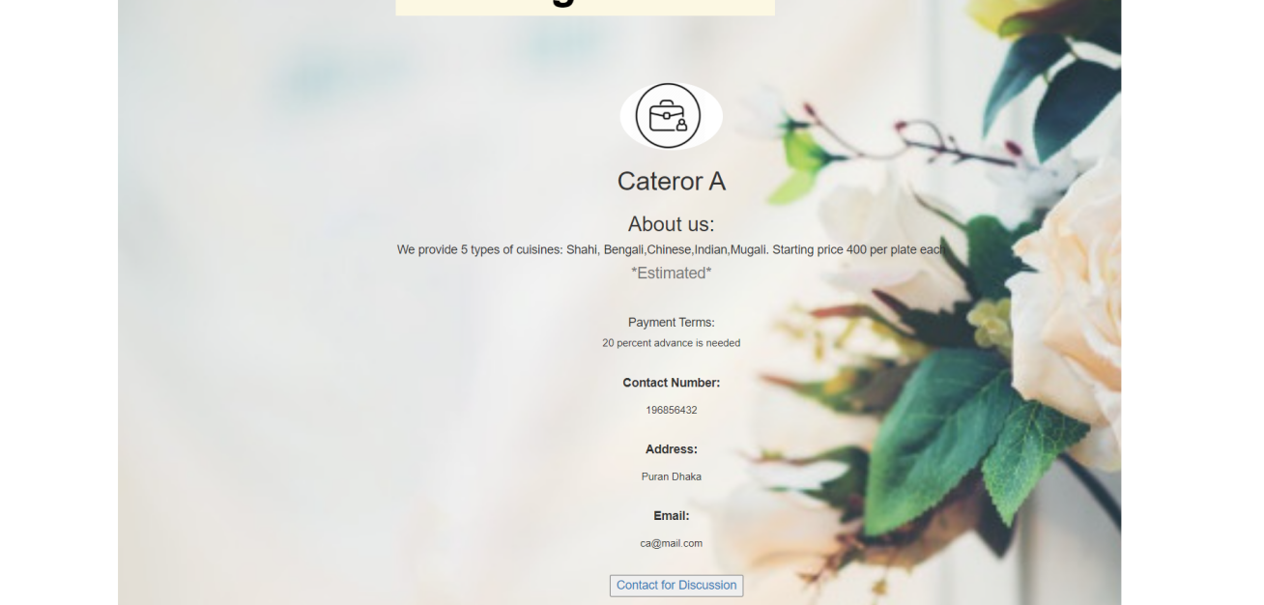

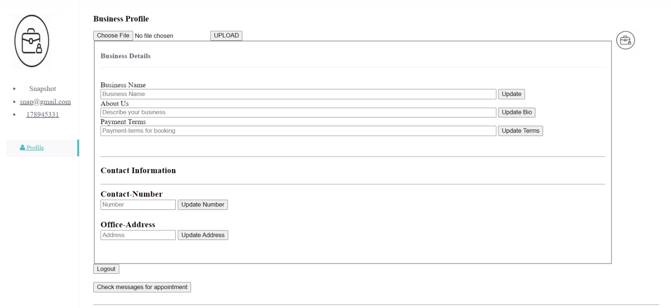

**Conclusion:**

Wedding Assist help will greatly help users and free them from the hassle of going from place to place looking for vendors as it is all under one roof.

Not only that vendors are getting a platform to showcase their work and make use of the platform to expand their business and this website is particularly targeted for their type of potential clients.

Contact information:

Sumaiya.sara@northsouth.edu